

Assignment – 2

• Connect to the Store Sales Data and do the following: -

− Remove all the blank rows.
− Update the column header if they are not updated
− Create a text table and show the sales in terms of
o Customers
o Product Category
o Regions

• Create a line and Clustered Column Chart showing the Sales and Discount as per the State or Province

− Format the bars and line with different colors
− Which state has the highest sales in terms Technology

• Create a Donut Chart showing sales in terms of Product category

• Create a Slicer and show the regions in dropdown. See how all the visuals mentioned above behaving when a particular region is selected.

Answer 1:
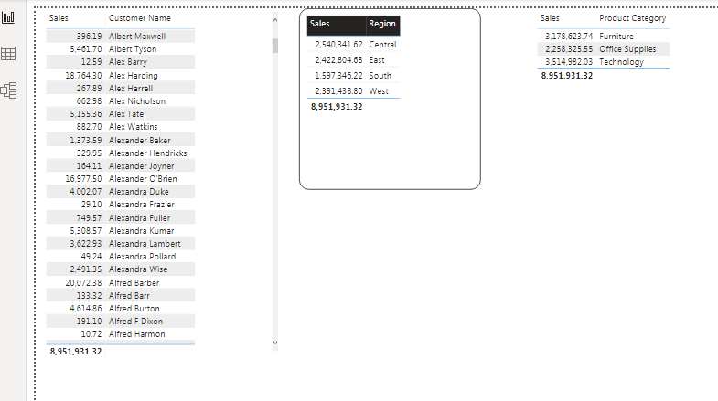

Answer 2:
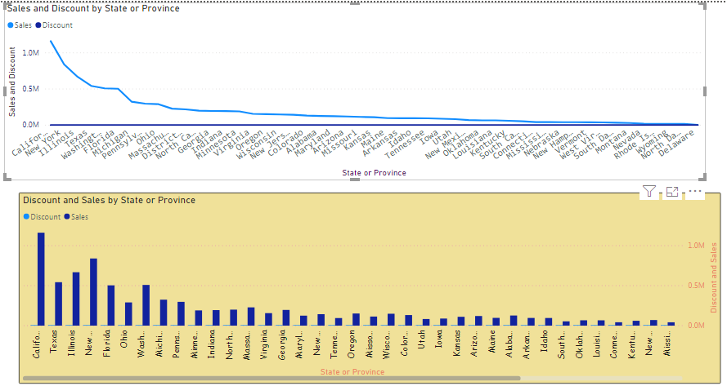

Answer 3:-
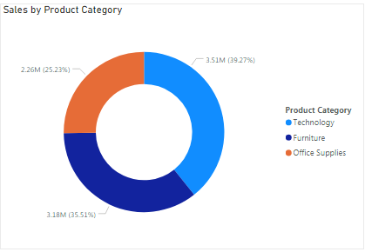

Answer 4:

